**LAPORAN TUGAS BESAR I**

**IF4021 PEMODELAN DAN SIMULASI**



Oleh:

  Doddy Aditya Wiranugraha   13517008

**PROGRAM STUDI TEKNIK INFORMATIKA**

**SEKOLAH TEKNIK ELEKTRO DAN INFORMATIKA**

**INSTITUT TEKNOLOGI BANDUNG**

**2021**

1. **Deskripsi Persoalan dan Solusi**
2. Event Kedatangan Orang

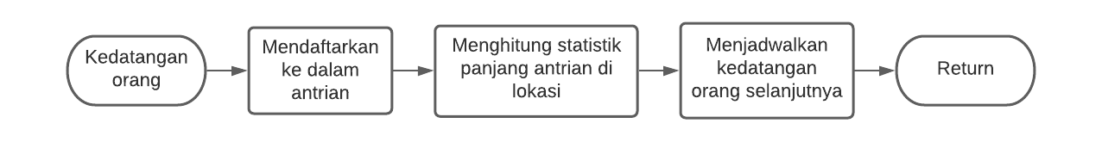

1. Event Keberangkatan Bis



1. Event Kedatangan Bis

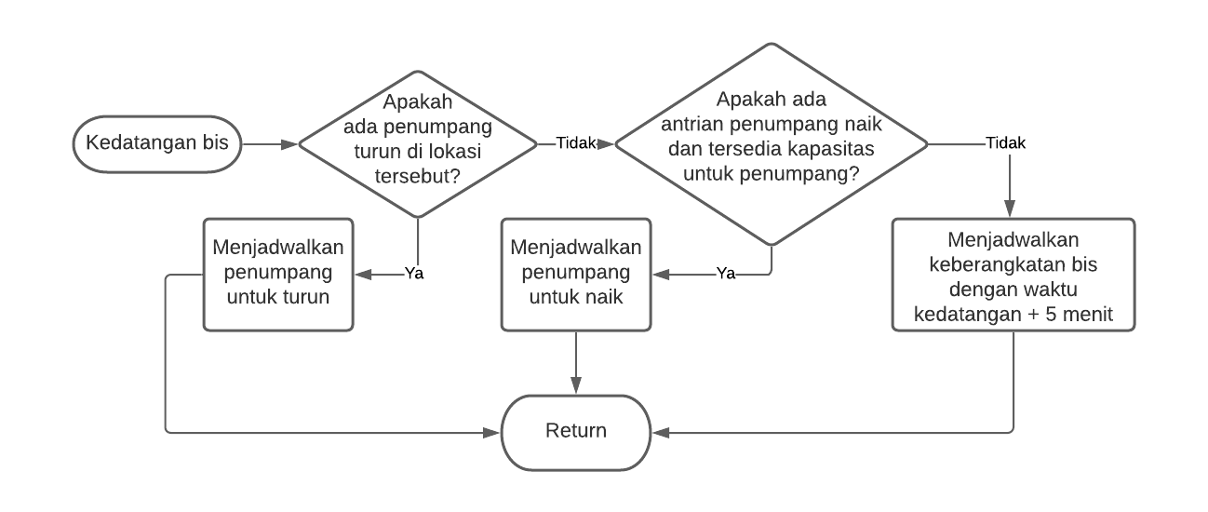

1. Event Penumpang Menaiki Bis

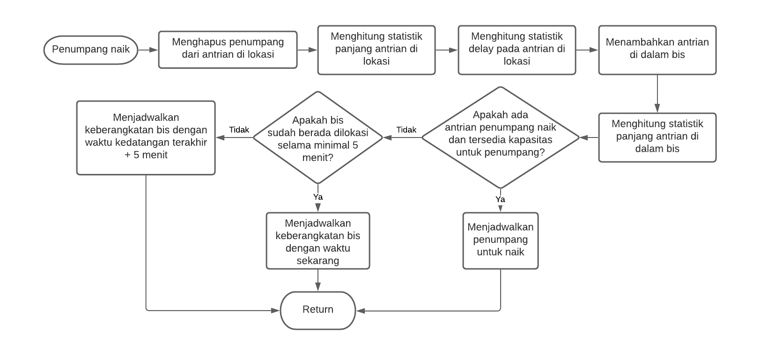

1. Event Penumpang Turun dari Bis

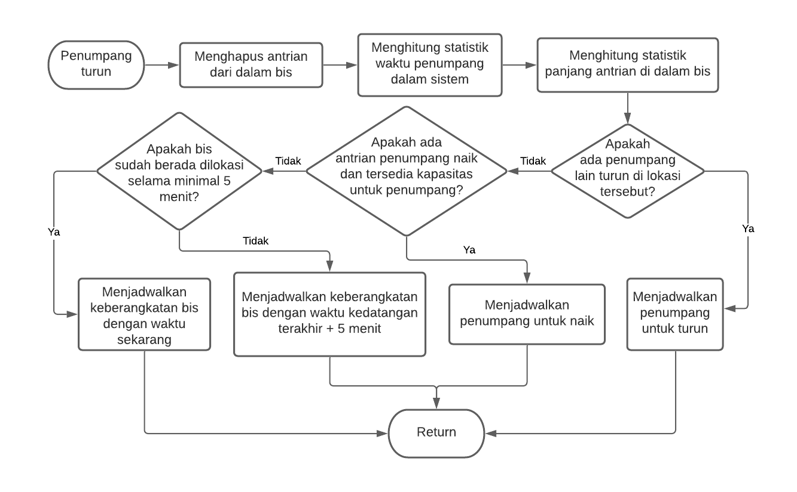

1. **Source Code**
2. car_rental.in

|  |
| --- |
| 3 2 80  14 10 24  30  0.583 1.00  16 24  15 25  0 1 0  0 0 4.5  4.5 0 0  5 |

1. car_rental.c

|  |
| --- |
| #include "simlib.h"  #define EVENT_PERSON_ARRIVAL 1  #define EVENT_BUS_ARRIVAL 2  #define EVENT_BUS_DEPARTURE 3  #define EVENT_UNLOADING 4  #define EVENT_LOADING 5  #define EVENT_END_SIMULATION 6  #define STREAM_INTERARRIVAL_1 1  #define STREAM_INTERARRIVAL_2 2  #define STREAM_INTERARRIVAL_3 3  #define STREAM_UNLOADING 4  #define STREAM_LOADING 5  #define STREAM_DESTINATION 6  #define LIST_TERMINAL_1 1  #define LIST_TERMINAL_2 2  #define LIST_CAR_RENTAL 3  #define LIST_TO_TERMINAL_1 4  #define LIST_TO_TERMINAL_2 5  #define LIST_TO_CAR_RENTAL 6  #define VARIABLE_TERMINAL_1 1  #define VARIABLE_TERMINAL_2 2  #define VARIABLE_CAR_RENTAL 3  #define VARIABLE_DELAY_TERMINAL_1 4  #define VARIABLE_DELAY_TERMINAL_2 5  #define VARIABLE_DELAY_CAR_RENTAL 6  #define VARIABLE_BUS 7  #define VARIABLE_PERSON 8  #define VARIABLE_BUS_STOP_TERMINAL_1 9  #define VARIABLE_BUS_STOP_TERMINAL_2 10  #define VARIABLE_BUS_STOP_CAR_RENTAL 11  #define VARIABLE_BUS_LOOP 12  #define TERMINAL_1 1  #define TERMINAL_2 2  #define CAR_RENTAL 3  #define MAX_NUM_LOCATION 3  #define MAX_RANGE 2  #define MAX_BUS_CAPACITY 20  int num_location, num_terminal, bus_capacity, bus_start_location, bus_stop_location;  double person_first_arrival, bus_last_arrival, bus_last_departure, bus_speed, bus_last_arrival, bus_min_time_process, length_simulation, prob_distrib_terminal[26], interarrival_time[MAX_NUM_LOCATION + 1],         load_uniform_distrib_terminal[MAX_RANGE + 1], unload_uniform_distrib_terminal[MAX_RANGE + 1],         route_distance[MAX_NUM_LOCATION + 1][MAX_NUM_LOCATION + 1];  FILE *infile, *outfile;  int recent_bus_capacity()  {    return (list_size[LIST_TO_TERMINAL_1] + list_size[LIST_TO_TERMINAL_2] + list_size[LIST_TO_CAR_RENTAL]);  }  void person_arrive(void)  {    if (transfer[3] == TERMINAL_1)    {      list_file(LAST, LIST_TERMINAL_1);      timest(list_size[LIST_TERMINAL_1], VARIABLE_TERMINAL_1);      transfer[3] = TERMINAL_1;      event_schedule(sim_time + expon(1 / interarrival_time[TERMINAL_1], STREAM_INTERARRIVAL_1), EVENT_PERSON_ARRIVAL);    }    else if (transfer[3] == TERMINAL_2)    {      list_file(LAST, LIST_TERMINAL_2);      timest(list_size[LIST_TERMINAL_2], VARIABLE_TERMINAL_2);      transfer[3] = TERMINAL_2;      event_schedule(sim_time + expon(1 / interarrival_time[TERMINAL_2], STREAM_INTERARRIVAL_2), EVENT_PERSON_ARRIVAL);    }    else    {      if (random_integer(prob_distrib_terminal, STREAM_DESTINATION) == 1)      {        transfer[3] = TERMINAL_1;      }      else      {        transfer[3] = TERMINAL_2;      }      list_file(LAST, LIST_CAR_RENTAL);      timest(list_size[LIST_CAR_RENTAL], VARIABLE_CAR_RENTAL);      transfer[3] = CAR_RENTAL;      event_schedule(sim_time + expon(1 / interarrival_time[CAR_RENTAL], STREAM_INTERARRIVAL_3), EVENT_PERSON_ARRIVAL);    }  }  void bus_arrive(void)  {    bus_last_arrival = transfer[1];    if (transfer[3] == TERMINAL_1)    {      transfer[3] = TERMINAL_1;      if (list_size[LIST_TO_TERMINAL_1] > 0)      {        event_schedule(sim_time + uniform(unload_uniform_distrib_terminal[1], unload_uniform_distrib_terminal[2], STREAM_UNLOADING), EVENT_UNLOADING);      }      else if (list_size[LIST_TERMINAL_1] > 0 && recent_bus_capacity() < MAX_BUS_CAPACITY)      {        event_schedule(sim_time + uniform(load_uniform_distrib_terminal[1], load_uniform_distrib_terminal[2], STREAM_LOADING), EVENT_LOADING);      }      else      {        event_schedule(bus_last_arrival + bus_min_time_process / 60, EVENT_BUS_DEPARTURE);      }    }    else if (transfer[3] == TERMINAL_2)    {      transfer[3] = TERMINAL_2;      if (list_size[LIST_TO_TERMINAL_2] > 0)      {        event_schedule(sim_time + uniform(unload_uniform_distrib_terminal[1], unload_uniform_distrib_terminal[2], STREAM_UNLOADING), EVENT_UNLOADING);      }      else if (list_size[LIST_TERMINAL_2] > 0 && recent_bus_capacity() < MAX_BUS_CAPACITY)      {        event_schedule(sim_time + uniform(load_uniform_distrib_terminal[1], load_uniform_distrib_terminal[2], STREAM_LOADING), EVENT_LOADING);      }      else      {        event_schedule(bus_last_arrival + bus_min_time_process / 60, EVENT_BUS_DEPARTURE);      }    }    else    {      transfer[3] = CAR_RENTAL;      if (list_size[LIST_TO_CAR_RENTAL] > 0)      {        event_schedule(sim_time + uniform(unload_uniform_distrib_terminal[1], unload_uniform_distrib_terminal[2], STREAM_UNLOADING), EVENT_UNLOADING);      }      else if (list_size[LIST_CAR_RENTAL] > 0 && recent_bus_capacity() < MAX_BUS_CAPACITY)      {        event_schedule(sim_time + uniform(load_uniform_distrib_terminal[1], load_uniform_distrib_terminal[2], STREAM_LOADING), EVENT_LOADING);      }      else      {        event_schedule(bus_last_arrival + bus_min_time_process / 60, EVENT_BUS_DEPARTURE);      }    }  }  void bus_depart(void)  {    if (transfer[3] == TERMINAL_1)    {      sampst(sim_time - bus_last_arrival, VARIABLE_BUS_STOP_TERMINAL_1);      transfer[3] = TERMINAL_2;      event_schedule(sim_time + route_distance[TERMINAL_1][TERMINAL_2] / bus_speed, EVENT_BUS_ARRIVAL);    }    else if (transfer[3] == TERMINAL_2)    {      sampst(sim_time - bus_last_arrival, VARIABLE_BUS_STOP_TERMINAL_2);      transfer[3] = CAR_RENTAL;      event_schedule(sim_time + route_distance[TERMINAL_2][CAR_RENTAL] / bus_speed, EVENT_BUS_ARRIVAL);    }    else    {      sampst(sim_time - bus_last_departure, VARIABLE_BUS_LOOP);      bus_last_departure = sim_time;      sampst(sim_time - bus_last_arrival, VARIABLE_BUS_STOP_CAR_RENTAL);      transfer[3] = TERMINAL_1;      event_schedule(sim_time + route_distance[CAR_RENTAL][TERMINAL_1] / bus_speed, EVENT_BUS_ARRIVAL);    }  }  void unload(void)  {    if (transfer[3] == TERMINAL_1)    {      list_remove(FIRST, LIST_TO_TERMINAL_1);      sampst(sim_time - transfer[1], VARIABLE_PERSON);      timest(recent_bus_capacity(), VARIABLE_BUS);      transfer[3] = TERMINAL_1;      if (list_size[LIST_TO_TERMINAL_1] > 0)      {        event_schedule(sim_time + uniform(unload_uniform_distrib_terminal[1], unload_uniform_distrib_terminal[2], STREAM_UNLOADING), EVENT_UNLOADING);      }      else if (list_size[LIST_TERMINAL_1] > 0 && recent_bus_capacity() < MAX_BUS_CAPACITY)      {        event_schedule(sim_time + uniform(load_uniform_distrib_terminal[1], load_uniform_distrib_terminal[2], STREAM_LOADING), EVENT_LOADING);      }      else      {        if ((sim_time - bus_last_arrival) < (bus_min_time_process / 60))        {          event_schedule(bus_last_arrival + bus_min_time_process / 60, EVENT_BUS_DEPARTURE);        }        else        {          event_schedule(sim_time, EVENT_BUS_DEPARTURE);        }      }    }    else if (transfer[3] == TERMINAL_2)    {      list_remove(FIRST, LIST_TO_TERMINAL_2);      sampst(sim_time - transfer[1], VARIABLE_PERSON);      timest(recent_bus_capacity(), VARIABLE_BUS);      transfer[3] = TERMINAL_2;      if (list_size[LIST_TO_TERMINAL_2] > 0)      {        event_schedule(sim_time + uniform(unload_uniform_distrib_terminal[1], unload_uniform_distrib_terminal[2], STREAM_UNLOADING), EVENT_UNLOADING);      }      else if (list_size[LIST_TERMINAL_2] > 0 && recent_bus_capacity() < MAX_BUS_CAPACITY)      {        event_schedule(sim_time + uniform(load_uniform_distrib_terminal[1], load_uniform_distrib_terminal[2], STREAM_LOADING), EVENT_LOADING);      }      else      {        if ((sim_time - bus_last_arrival) < (bus_min_time_process / 60))        {          event_schedule(bus_last_arrival + bus_min_time_process / 60, EVENT_BUS_DEPARTURE);        }        else        {          event_schedule(sim_time, EVENT_BUS_DEPARTURE);        }      }    }    else    {      list_remove(FIRST, LIST_TO_CAR_RENTAL);      sampst(sim_time - transfer[1], VARIABLE_PERSON);      timest(recent_bus_capacity(), VARIABLE_BUS);      transfer[3] = CAR_RENTAL;      if (list_size[LIST_TO_CAR_RENTAL] > 0)      {        event_schedule(sim_time + uniform(unload_uniform_distrib_terminal[1], unload_uniform_distrib_terminal[2], STREAM_UNLOADING), EVENT_UNLOADING);      }      else if (list_size[LIST_CAR_RENTAL] > 0 && recent_bus_capacity() < MAX_BUS_CAPACITY)      {        event_schedule(sim_time + uniform(load_uniform_distrib_terminal[1], load_uniform_distrib_terminal[2], STREAM_LOADING), EVENT_LOADING);      }      else      {        if ((sim_time - bus_last_arrival) < (bus_min_time_process / 60))        {          event_schedule(bus_last_arrival + bus_min_time_process / 60, EVENT_BUS_DEPARTURE);        }        else        {          event_schedule(sim_time, EVENT_BUS_DEPARTURE);        }      }    }  }  void load(void)  {    if (transfer[3] == TERMINAL_1)    {      list_remove(FIRST, LIST_TERMINAL_1);      person_first_arrival = transfer[1];      timest(list_size[LIST_TERMINAL_1], VARIABLE_TERMINAL_1);      sampst(sim_time - transfer[1], VARIABLE_DELAY_TERMINAL_1);      transfer[1] = person_first_arrival;      list_file(LAST, LIST_TO_CAR_RENTAL);      timest(recent_bus_capacity(), VARIABLE_BUS);      transfer[3] = TERMINAL_1;      if (list_size[LIST_TERMINAL_1] > 0 && recent_bus_capacity() < MAX_BUS_CAPACITY)      {        event_schedule(sim_time + uniform(load_uniform_distrib_terminal[1], load_uniform_distrib_terminal[2], STREAM_LOADING), EVENT_LOADING);      }      else      {        if ((sim_time - bus_last_arrival) < (bus_min_time_process / 60))        {          event_schedule(bus_last_arrival + bus_min_time_process / 60, EVENT_BUS_DEPARTURE);        }        else        {          event_schedule(sim_time, EVENT_BUS_DEPARTURE);        }      }    }    else if (transfer[3] == TERMINAL_2)    {      list_remove(FIRST, LIST_TERMINAL_2);      person_first_arrival = transfer[1];      timest(list_size[LIST_TERMINAL_2], VARIABLE_TERMINAL_2);      sampst(sim_time - transfer[1], VARIABLE_DELAY_TERMINAL_2);      transfer[1] = person_first_arrival;      list_file(LAST, LIST_TO_CAR_RENTAL);      timest(recent_bus_capacity(), VARIABLE_BUS);      transfer[3] = TERMINAL_2;      if (list_size[LIST_TERMINAL_2] > 0 && recent_bus_capacity() < MAX_BUS_CAPACITY)      {        event_schedule(sim_time + uniform(load_uniform_distrib_terminal[1], load_uniform_distrib_terminal[2], STREAM_LOADING), EVENT_LOADING);      }      else      {        if ((sim_time - bus_last_arrival) < (bus_min_time_process / 60))        {          event_schedule(bus_last_arrival + bus_min_time_process / 60, EVENT_BUS_DEPARTURE);        }        else        {          event_schedule(sim_time, EVENT_BUS_DEPARTURE);        }      }    }    else    {      list_remove(FIRST, LIST_CAR_RENTAL);      int destination = transfer[3];      person_first_arrival = transfer[1];      timest(list_size[LIST_CAR_RENTAL], VARIABLE_CAR_RENTAL);      sampst(sim_time - transfer[1], VARIABLE_DELAY_CAR_RENTAL);      transfer[1] = person_first_arrival;      if (destination == 1)      {        list_file(LAST, LIST_TO_TERMINAL_1);      }      else      {        list_file(LAST, LIST_TO_TERMINAL_2);      }      timest(recent_bus_capacity(), VARIABLE_BUS);      transfer[3] = CAR_RENTAL;      if (list_size[LIST_CAR_RENTAL] > 0 && recent_bus_capacity() < MAX_BUS_CAPACITY)      {        event_schedule(sim_time + uniform(load_uniform_distrib_terminal[1], load_uniform_distrib_terminal[2], STREAM_LOADING), EVENT_LOADING);      }      else      {        if ((sim_time - bus_last_arrival) < (bus_min_time_process / 60))        {          event_schedule(bus_last_arrival + bus_min_time_process / 60, EVENT_BUS_DEPARTURE);        }        else        {          event_schedule(sim_time, EVENT_BUS_DEPARTURE);        }      }    }  }  void report(void)  {    fprintf(outfile, "\n\n----------------------------STATISTIC REPORT IN HOUR----------------------------\n\n");    fprintf(outfile, "a. Average and maximum number in each queue\n");    fprintf(outfile, "Location          ");    fprintf(outfile, "Average number         ");    fprintf(outfile, "Maximum number\n");    for (int i = VARIABLE_TERMINAL_1; i <= VARIABLE_CAR_RENTAL; i++)    {      timest(0.0, -i);      if (i < MAX_NUM_LOCATION)      {        fprintf(outfile, "Terminal %d%17.3f%23.3f\n", i, transfer[1], transfer[2]);      }      else      {        fprintf(outfile, "Car rental %16.3f%23.3f\n", transfer[1], transfer[2]);      }    }    fprintf(outfile, "\nb. Average and maximum delay in each queue\n");    fprintf(outfile, "Location          ");    fprintf(outfile, "Average delay          ");    fprintf(outfile, "Maximum delay\n");    int j = 1;    for (int i = VARIABLE_DELAY_TERMINAL_1; i <= VARIABLE_DELAY_CAR_RENTAL; i++)    {      sampst(0.0, -i);      if (i < VARIABLE_DELAY_CAR_RENTAL)      {        fprintf(outfile, "Terminal %d%17.3f%23.3f\n", j, transfer[1], transfer[3]);      }      else      {        fprintf(outfile, "Car rental %16.3f%23.3f\n", transfer[1], transfer[3]);      }      j++;    }    fprintf(outfile, "\nc. Average and maximum number on the bus\n");    fprintf(outfile, "Average number    ");    fprintf(outfile, "Maximum number\n");    timest(0.0, -VARIABLE_BUS);    fprintf(outfile, "%.3f%22.3f\n", transfer[1], transfer[2]);    fprintf(outfile, "\nd. Average, maximum, and minimum time the bus stopped in each location\n");    fprintf(outfile, "Location          ");    fprintf(outfile, "Average time           ");    fprintf(outfile, "Maximum time          ");    fprintf(outfile, "Minimum time\n");    j = 1;    for (int i = VARIABLE_BUS_STOP_TERMINAL_1; i <= VARIABLE_BUS_STOP_CAR_RENTAL; i++)    {      sampst(0.0, -i);      if (i < VARIABLE_BUS_STOP_CAR_RENTAL)      {        fprintf(outfile, "Terminal %d%17.3f%23.3f%21.3f\n", j, transfer[1], transfer[3], transfer[4]);      }      else      {        fprintf(outfile, "Car rental %16.3f%23.3f%21.3f\n", transfer[1], transfer[3], transfer[4]);      }      j++;    }    fprintf(outfile, "\ne. Average, maximum, and minimum the bus to make a loop\n");    fprintf(outfile, "Average time      ");    fprintf(outfile, "Maximum time           ");    fprintf(outfile, "Minimum time\n");    sampst(0.0, -VARIABLE_BUS_LOOP);    fprintf(outfile, "%.3f%22.3f%23.3f\n", transfer[1], transfer[3], transfer[4]);    fprintf(outfile, "\nf. Average, maximum, and minimum time person is in the system\n");    fprintf(outfile, "Average time      ");    fprintf(outfile, "Maximum time           ");    fprintf(outfile, "Minimum time\n");    sampst(0.0, -VARIABLE_PERSON);    fprintf(outfile, "%.3f%22.3f%23.3f\n", transfer[1], transfer[3], transfer[4]);  }  void log_event()  {    switch (next_event_type)    {    case EVENT_PERSON_ARRIVAL:      printf("%.2lf EVENT_ARRIVAL_PERSON %f\n", sim_time, transfer[3]);      break;    case EVENT_BUS_ARRIVAL:      printf("%.2lf EVENT_ARRIVAL_BUS %f\n", sim_time, transfer[3]);      break;    case EVENT_BUS_DEPARTURE:      printf("%.2lf EVENT_DEPARTURE_BUS %f\n", sim_time, transfer[3]);      break;    case EVENT_UNLOADING:      printf("%.2lf EVENT_UNLOADING %f\n", sim_time, transfer[3]);      break;    case EVENT_LOADING:      printf("%.2lf EVENT_LOADING %f\n", sim_time, transfer[3]);      break;    }  }  int main()  {    infile = fopen("car_rental.in", "r");    outfile = fopen("car_rental.out", "w");    fscanf(infile, "%d %d %lg", &num_location, &num_terminal, &length_simulation);    for (int i = 1; i <= num_location; i++)    {      fscanf(infile, "%lg", &interarrival_time[i]);    }    fscanf(infile, "%lg %d", &bus_speed, &bus_start_location);    for (int i = 1; i <= num_terminal; i++)    {      fscanf(infile, "%lg", &prob_distrib_terminal[i]);    }    for (int i = 1; i <= MAX_RANGE; i++)    {      fscanf(infile, "%lg", &unload_uniform_distrib_terminal[i]);    }    for (int i = 1; i <= MAX_RANGE; i++)    {      fscanf(infile, "%lg", &load_uniform_distrib_terminal[i]);    }    for (int i = 1; i <= MAX_NUM_LOCATION; i++)    {      for (int j = 1; j <= MAX_NUM_LOCATION; j++)      {        fscanf(infile, "%lg", &route_distance[i][j]);      }    }    fscanf(infile, "%lg", &bus_min_time_process);    fprintf(outfile, "Car Rental Model\n\n");    fprintf(outfile, "Number of location%31d\n\n", num_location);    fprintf(outfile, "Number of terminal%31d\n\n", num_terminal);    fprintf(outfile, "Route distance from 1 to 2%25.1f mile\n\n", route_distance[1][2]);    fprintf(outfile, "Route distance from 2 to 3%25.1f miles\n\n", route_distance[2][3]);    fprintf(outfile, "Route distance from 3 to 1%25.1f miles\n\n", route_distance[3][1]);    fprintf(outfile, "Bus speed%43.1f miles per hour\n\n", bus_speed);    fprintf(outfile, "Minimum time spent by bus%26.1f minutes\n\n", bus_min_time_process);    fprintf(outfile, "Distribution function of unloading          ");    for (int i = 1; i <= num_terminal; i++)    {      i == 2 ? fprintf(outfile, "%7.1f", prob_distrib_terminal[i]) : fprintf(outfile, "%9.3f", prob_distrib_terminal[i]);    }    fprintf(outfile, "\n");    fprintf(outfile, "in each terminal\n\n");    fprintf(outfile, "Interarrival rate per hour on each location");    for (int i = 1; i <= num_location; i++)    {      i == 1 ? fprintf(outfile, "%9.1f", interarrival_time[i]) : fprintf(outfile, "%9.1f", interarrival_time[i]);    }    fprintf(outfile, "\n\n");    fprintf(outfile, "Uniform distribution of unloading time range");    for (int i = 1; i <= MAX_RANGE; i++)    {      i == 1 ? fprintf(outfile, "%8.1f - ", unload_uniform_distrib_terminal[i]) : fprintf(outfile, "%.1f seconds each person", unload_uniform_distrib_terminal[i]);    }    fprintf(outfile, "\n\n");    fprintf(outfile, "Uniform distribution of loading time range  ");    for (int i = 1; i <= MAX_RANGE; i++)    {      i == 1 ? fprintf(outfile, "%8.1f - ", load_uniform_distrib_terminal[i]) : fprintf(outfile, "%.1f seconds each person", load_uniform_distrib_terminal[i]);    }    fprintf(outfile, "\n\n");    fprintf(outfile, "Length of simulation%32.1f hours", length_simulation);    init_simlib();    for (int i = 1; i <= MAX_RANGE; i++)    {      unload_uniform_distrib_terminal[i] = unload_uniform_distrib_terminal[i] / 3600;      load_uniform_distrib_terminal[i] = load_uniform_distrib_terminal[i] / 3600;    }    for (int i = 1; i <= num_location; i++)    {      transfer[3] = i;      event_schedule(expon(1 / interarrival_time[i], i), EVENT_PERSON_ARRIVAL);    }    transfer[3] = TERMINAL_1;    event_schedule(route_distance[CAR_RENTAL][TERMINAL_1] / bus_speed, EVENT_BUS_ARRIVAL);    event_schedule(length_simulation, EVENT_END_SIMULATION);    do    {      timing();      switch (next_event_type)      {      case EVENT_PERSON_ARRIVAL:        person_arrive();        break;      case EVENT_BUS_ARRIVAL:        bus_arrive();        break;      case EVENT_BUS_DEPARTURE:        bus_depart();        break;      case EVENT_UNLOADING:        unload();        break;      case EVENT_LOADING:        load();        break;      case EVENT_END_SIMULATION:        report();        break;      }    } while (next_event_type != EVENT_END_SIMULATION);    fclose(infile);    fclose(outfile);    return 0;  } |

1. **Output Program**

|  |
| --- |
| Car Rental Model  Number of location 3  Number of terminal 2  Route distance from 1 to 2 1.0 mile  Route distance from 2 to 3 4.5 miles  Route distance from 3 to 1 4.5 miles  Bus speed 30.0 miles per hour  Minimum time spent by bus 5.0 minutes  Distribution function of unloading 0.583 1.0  in each terminal  Interarrival rate per hour on each location 14.0 10.0 24.0  Uniform distribution of unloading time range 16.0 - 24.0 seconds each person  Uniform distribution of loading time range 15.0 - 25.0 seconds each person  Length of simulation 80.0 hours  ----------------------------STATISTIC REPORT IN HOUR----------------------------  a. Average and maximum number in each queue  Location Average number Maximum number  Terminal 1 7.588 27.000  Terminal 2 4.927 17.000  Car rental 9.387 30.000  b. Average and maximum delay in each queue  Location Average delay Maximum delay  Terminal 1 0.539 1.633  Terminal 2 0.501 2.214  Car rental 0.405 1.123  c. Average and maximum number on the bus  Average number Maximum number  13.855 20.000  d. Average, maximum, and minimum time the bus stopped in each location  Location Average time Maximum time Minimum time  Terminal 1 0.112 0.170 0.083  Terminal 2 0.091 0.155 0.083  Car rental 0.190 0.229 0.098  e. Average, maximum, and minimum the bus to make a loop  Average time Maximum time Minimum time  0.726 0.793 0.600  f. Average, maximum, and minimum time person is in the system  Average time Maximum time Minimum time  0.761 2.476 0.183 |